ADVISORY NOTICE

ADVISORY NOTICE 001/FEB/2021 – UPDATE 002

- Category: SMALL VESSEL CONCENTRATION.

- Time: 02 FEB 2021 at 1530UTC.

- Description: UKMTO has been informed by an MV that there is a concentration of 10 small craft in the vicinity of ITRC Point A.

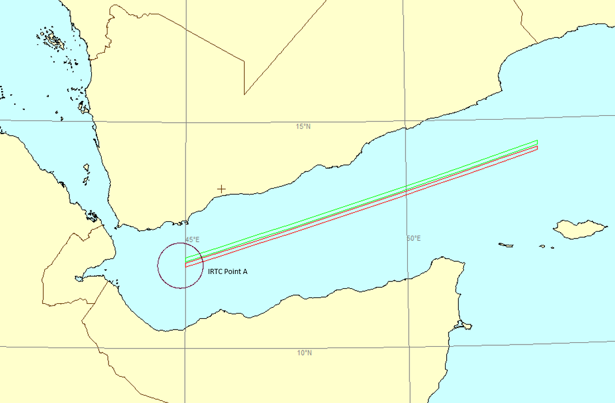

- Source: Master.

VESSELS TRANSITING THE AREA ARE ADVISED TO EXERCISE CAUTION

This information is provided to inform maritime situational awareness for mariners operating in the region. UKMTO is not responsible for the accuracy of this reporting.

UKMTO Watchkeeper
Email: watchkeepers@ukmto.org
Emergency Tel: +44 (0)2392 222060
Emergency Tel: +971 5055 23215
General Enquiries: +44 (0)2392 222065
www.ukmto.org

