UKMTO ADVISORY |  | Latitude: | Longitude:
 |  | 26°26´48N | 056°11´18E
001/JUN/2023 |  | Incident Date: | Incident Time:
Source: MASTER |  | 04/JUN/2023 | 1235UTC
Issued: 1614ZJUN23UTC
SUSPICIOUS ACTIVITY
UKMTO has been made aware of a MV being approached by 3 small craft, carrying armed personnel in an area 27nm miles north of Mina Saqr.
Vessel conducted self-protection manoeuvres iaw BMP5, small boats departed the area after 30 minutes.
Vessel and crew are SAFE .
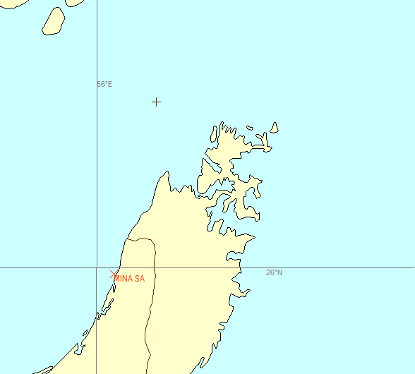
VESSELS TRANSITING THE AREA ARE ADVISED TO EXERCISE CAUTION

 | This ADVISORY has been compiled from information provided by 3rd parties and has not been verified by UKMTO. The information is provided to inform the maritime situational awareness of mariners operating in the region. UKMTO is not responsible for the accuracy of this reporting.
UKMTO Watchkeeper  Email: watchkeepers@ukmto.org  Emergency Tel: +44 (0)2392 222060  Website: www.ukmto.org |  | U K M T O  United Kingdom Maritime Trade Operations

